Youth Bowler Satisfaction
Survey Template

- Please specify your gender
- Male
- Female
- Please select which option best describes you
- USBC Youth member
- Parent or guardian of USBC Youth member
- Please select which age range best describes you
- 8 and under
- 9 – 14 years old
- 15 – 18 years old
- 21+ (parent or guardian)
- Overall, how satisifed are you with the coaching you received this season?
- Very satisfied
- Somewhat satisfied
- Neither satisfied no dissatisfied
- Somewhat dissatisfied
- Very dissatisfied
- How responsive has our association been to your questions or concerns about our products and services?
- Extremely responsive
- Very responsive
- Moderately responsive
- Not so responsive
- Not at all responsive
- Not applicable
- How well did the awards and recognition opportunities meet your needs?
- Extremely well
- Very well
- Somewhat well
- Not so well
- Not at all well

- How long have you been a USBC Youth member?
- This is my first year
- Second year
- 3 – 5 years
- 6 – 10 years
- 11+ years
- How likely are you to bowl again next season?
- Extremely likely
- Very likely
- Somewhat likely
- Not so likely
- Not at all likely
- How well did your youth bowling experience meet your overall activity needs?
- Extremely well
- Very well
- Somewhat well
- Not so well
- Not at all well
- How likely is it that you would recommend bowling to a friend?
1-10 scale: 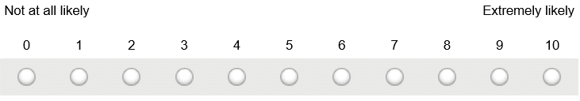
- What are the reasons you enjoy bowling? (check all that apply)
- Competition
- Scholarship
- Coaching
- Awards
- It’s fun
- Team atmosphere
- Seeing improvement
- Tournaments

- Do you have any other comments, questions, or concerns?

